North Carolina International Association for Identification Photography Contest

Two Categories:

**Forensics**: Forensics in the lab or field & police related activity

**Open**: Everything else (portraits, landscapes, sports, etc.)

Digitally Submit

Color or B&W.

Limit of 4 photographs per person.

Due by: Monday, October 7, 2024 at 5pm

Email Submissions to:

[melissa.southern@wake.gov](mailto:melissa.southern@wake.gov)

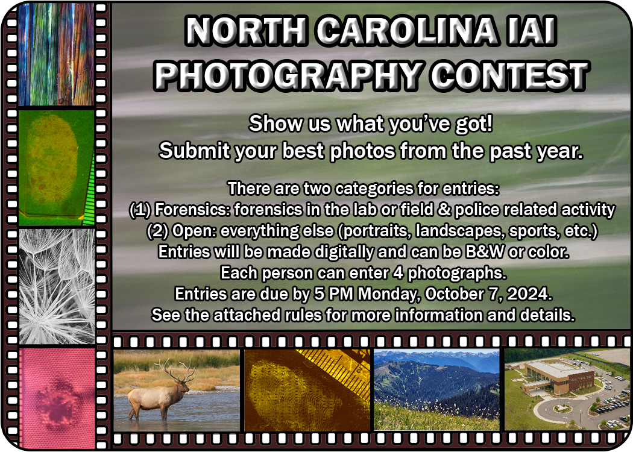

**RULES OF THE NCIAI PHOTOGRAPHY CONTEST**

The purpose of the North Carolina International Association for Identification Photography Contest is to promote and recognize excellence in photography among the membership.

* The photography contest will be held once a year at the NCIAI conference.
* The contest will be coordinated by the Awards and Goodwill Committee.
* Entrants must be NCIAI members.
* All entries must be photographed by the entrant. An entrant may submit up to four photographs. Those four photographs can be in either or both categories. DO not enter photographs that have already been entered into this contest in previous years.
* There are two categories for entries: Forensics and Open. The Forensics category will encompass any photographs related to forensics (scene and lab) and police related activity. The Open category will encompass all other entries and can be of any subject from portraits to sports, from landscapes to weddings. The entrant must choose the appropriate category upon submission.
* Entries will be made digitally. They should be a minimum of 3400 pixels on the shortest side. Entries may be in color or black and white. A cell phone image is also acceptable. For cell phone images, please submit a full-sized image without any editing completed in the phone as this degrades the image. You can edit images in Adobe Photoshop or some similar program in the computer, however, this is not a digital art competition. The photographs should remain photographs and be true to the way that they were originally captured.
* Entries will be emailed to: [melissa.southern@wake.gov](mailto:melissa.southern@wake.gov) by 5 PM on Monday, October 7, 2024. Each entrant may enter up to four photographs.
* The following information must be included in the email along with the entry:
  + Name of Photographer
  + Agency
  + Contact Information (phone number, email address, etc.)
  + Category (Forensics or Open)
  + Date photograph was taken
  + Title and Description of photograph
* The Awards and Goodwill Committee will print each photograph as submitted and mount them on foam core or similar material for display at the 2024 NCIAI Conference.
* The criteria for judging are subject matter, photography skill, and impact of the photograph.
* The Awards and Goodwill Committee will appoint two judges for a three-judge panel. The First Vice-President of the NCIAI shall serve as the third judge. If any judge is unable to complete their duties, the Awards and Goodwill Committee will appoint a replacement for that judge.
* The first place winner in each category will be awarded a plaque and a $100 prize. The second place winner in each category will be awarded at $25 prize. Each entrant will receive a Certificate of Participation.
* Awards will be presented during the banquet on Tuesday, October 29, 2024.
* All entries will be exhibited throughout the day on Monday, October 28 and Tuesday, October 29, 2024 and at the banquet.
* Entrants may take possession of the printed versions of their entries following the banquet and by the end of the conference on Wednesday, October 30, 2024. Any prints not claimed by the end of the conference will be disposed of by the NCIAI.